PROBLEM STATEMENT

(IOT BASED REAL TIME RIVER WATER QUALITY MONITORING AND CONTROL SYSTEM)

* Current water quality monitoring system is a manual with a monotonous process and is very time consuming.
* Real time data access can be done by using remote monitoring and IOT technology.
* Proposed paper is to obtain the water monitoring system with high frequency, high mobility and low powered.

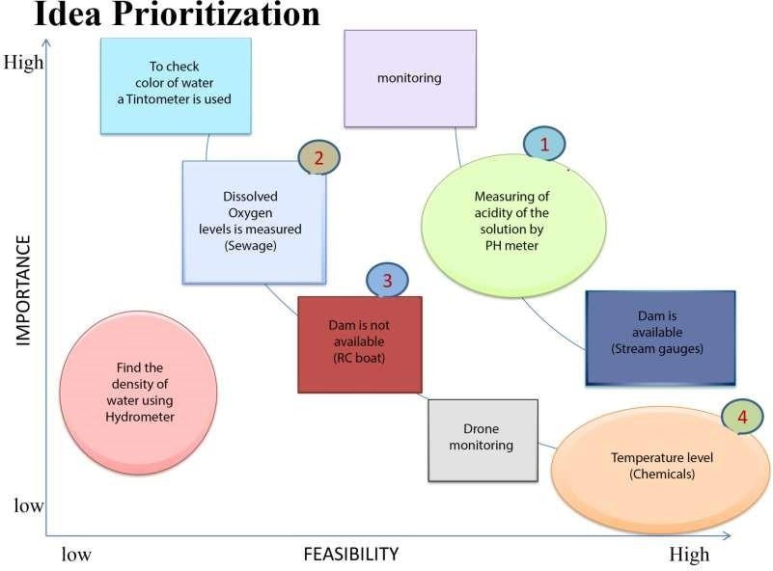

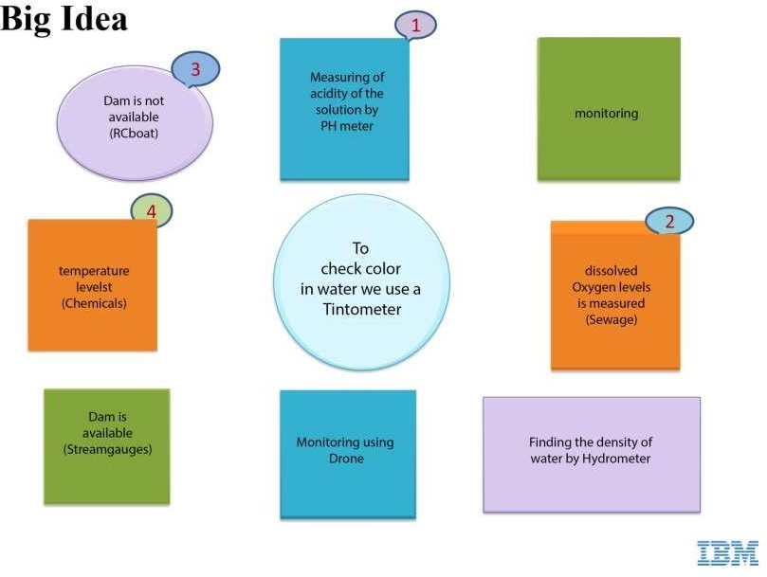

# TEAM LEADER

Bhavatarini M 732919ECR018

# TEAM MEMBERS

Aravinth S 732919ECR011 Aishwarya 732919ECR006 Anitha S 732919ECR008